Question1:
a): Verify the two distributions p(θ) and p(φ) integrate to 1:
The range for θ is 0 to $π$ and the range for φ is 0 to $2π$.
c): graph the sample points chosen:
The graph below is the point picked by the random generator and converted into 3D cartesian coordinates.
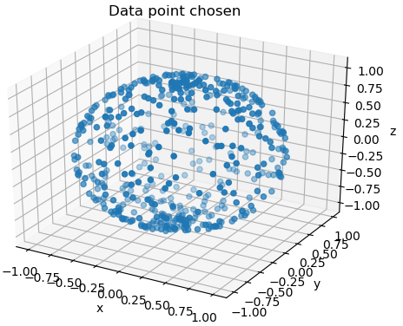
d): Calculate the land percentage in from the data provided.
The program is implemented in Lab10Q1.py, and from the data we calculate the land covers about 26.8% (0.26880369084362143) of the total area of the earth.
e): How many samples do you need to get 10% accuracy, 0.1% accuracy, 0.001% accuracy?
In trail and run, we determine that if you want to get 10% accuracy consistently, we need to have at least 50 data points selected. For the 0.1% and 0.001%, we had a hard time constantly achieve that accuracy with sample points > 1,000,000 sample points.
Question2:
b): Plot the histogram, I(µ) vs µ graph and find the limb-darkening coefﬁcients using linear regression with τ = 10
The code for this question is implemented as Lab10Q2.py. The plot generated by the code is shown below:
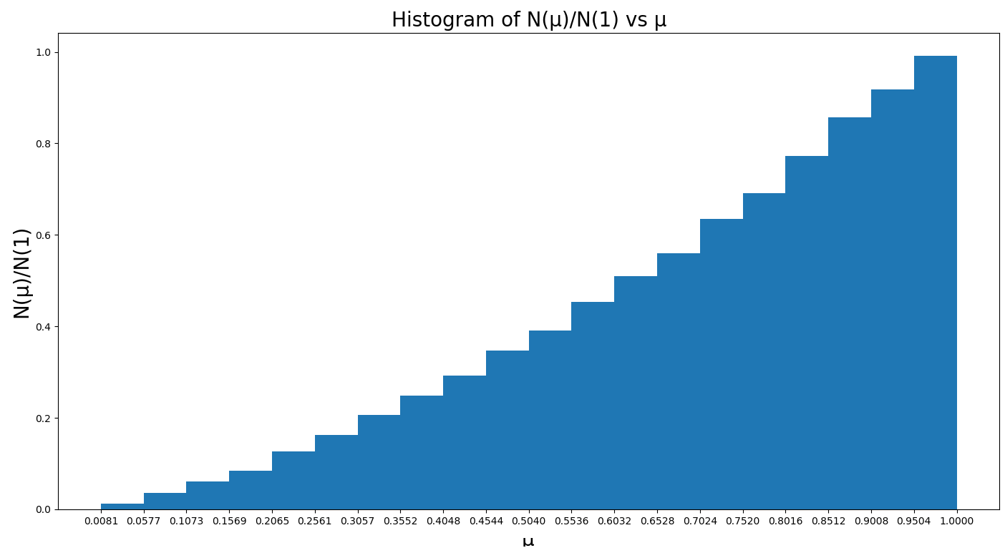
The next graph shows the intensity of the light vs angle of scatter:
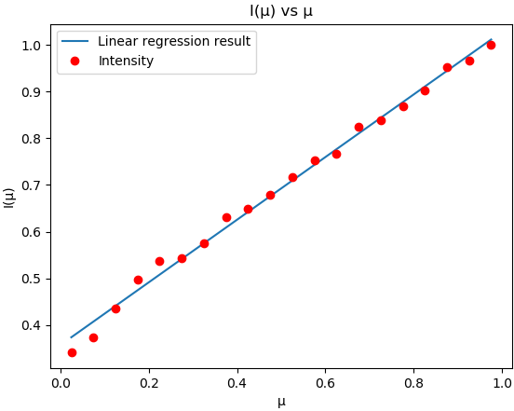
For the linear regression, the slop we caculated is 0.66445532 with vertical shift value of 0.37225148 compare to equation (1)’s value, our linear regression result is fairly close.
c): Plot the histogram, I(µ) vs µ graph and find the limb-darkening coefﬁcients using linear regression with τ = 0.0001.
The code for this question is implemented as Lab10Q2.py. The plot generated by the code is shown below:
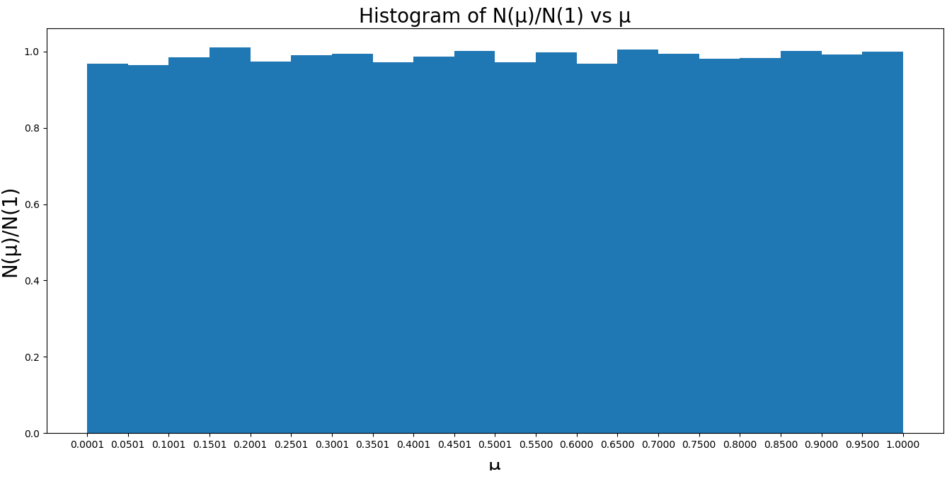
Our expectation for the angular distribution is a uniform distribution, and the graph generate by the code agree with our expectation. However, the light intensity graph caught us by surprise, we initially thought that the intensity should be a uniform distribution too, but instead the intensity graph looks like below:
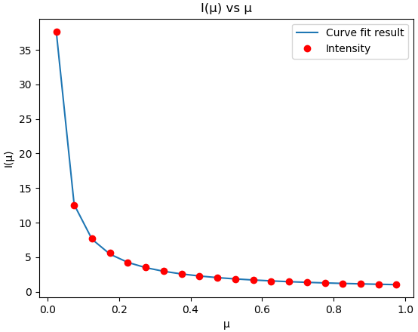
For this graph, we use a/x +b as our fitting function, the coefficient for a is 0.94141144 and the vertical shift component is 0.05403614. Our interpretation of the result is that since the light intensity emit for a plane view at 90-degree angle is calculate as number of photons / unit area. Since the photons are emits uniformly to different angles. If we view the plane at an angle, that means that the area of the plane will be effectively smaller, hence increase brightness.

